**let & const**

**let:** variable value

**const:** constant value

**Arrow function:**

No more issues with the **this** keyword. Always keeps its context (No surprises).

Sample arrow function

const/let functionname = (param1, param2, param3…) => {

Function implementation

}

→ if you have only one parameter, following works

let/const functionname = oneandonlyoneparam => {

Function implementation

}

→ function body alternatives

If a function purpose is just to return, then we can write it as follows

let/const functionname = (params) => function implementation

**this:**

Alternates (specially with params)

**Exports & Imports (Modules)**

Default export:

When imported, the default exported function is imported

Named imports

When imported, we need to specify which named export functions we are trying to import

**Example:**

|  |  |  |  |
| --- | --- | --- | --- |
| **Default export** | **Named export** | **Import** |  |
| File: porson.js | File: utility.js | File: app.js |  |
| Const person = {  name: ‘Max’  }  export **default** person | export const clean = () => {.....}  export const baseData = 10; | Import prsn from ‘/.person.js’  import {clean} from ‘/.utility.js’  import {baseData} from ‘/.utility.js’ |  |

---> we can use alias for named exports while importing them, using the key word **as**

Example, when we import named export from above code, we can import them as follows

Import {clean as CleanCode} from ‘./utility.js’

Import {baseData as BasicData} from ‘./utility.js’

---> we can use **\*** key word to import all named exports

import * as bundled from ‘/.utility.js’

**Classes**

Constructor syntax **constructor**

Class Person {

constructor(){

This.name = ‘Venu’;

}

printMyName() {

console.log(this.name);

}

}

const person = new Person();

person.printMyName();

---> directly initialize class’s global variable.

**Inheritance**

**--->** Use **extends** key word to inherit from parent;

---> Use **super()** in child class’s constructor if the child class has constructor

class ParentCls {

constructor(){

console.log('ParentCls obj created');

}

printFromParent(){

console.log('Print from ParentCls');

}

}

class Kid1Cls extends ParentCls {

printFromKid1(){

console.log('Print from Kid1');

}

}

class Kid2Cls extends ParentCls {

constructor(){

super();

}

printFromKid2() {

console.log('Print from Kid2');

}

}

const parentObj = new ParentCls();

const kid1Obj = new Kid1Cls();

const kid2Obj = new Kid2Cls();

parentObj.printFromParent();

kid1Obj.printFromKid1();

kid1Obj.printFromParent();

kid2Obj.printFromKid2();

kid2Obj.printFromParent();

**Install React**

npm install -g create-react-app

Create React application

create-react-app <application name>

Run the application

npm start

**React class**

Import React, {Component} from ‘react’;

Import ‘./App.css’;

Class App extends Component {

render() {

Return (<div className=”style1”>Hi</div>);

}

}

export default App;

Vscode setting for ES6:

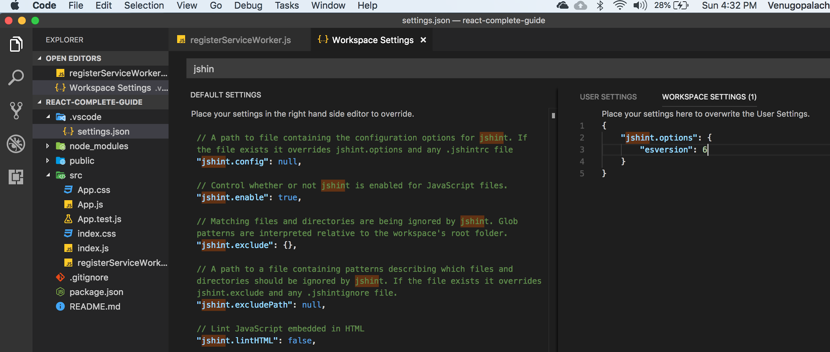

* **registerServiceWorker**

This will precache our javascript files.

→ Every react class renders a return html (jsx);

--->

return (<div>blah blah…</div>);

becomes

React.createElement(‘html element’, ‘javascript object with configuration’, ‘children elements’)

--->

React.createElement(‘html element’, {className: ‘style1’}, ------........

JSX Restrictions

|  |  |  |
| --- | --- | --- |
| No | Instead |  |
| class | className |  |
|  |  |  |
|  |  |  |

React library provides jsx’s html tags

No multiple root tags in class’s render’s return.

R

---> folder starts with caps like ‘Person’

---> js file name starts with caps like ‘Person.js’

---> class name starts with caps like

class App extends Component {

---> function name starts with lowercase like

function person() {}

const person

A component is a function that returns some JSX (HTML)

---> imported object should start with caps like

import Person from './Person/Person';

---> in react IN in JSX all elements with lower case characters like div, h1….. Are reserved for native html elements… So for custom components start with caps so that react wouldn’t interfere with native elements, for example we can have our own custom element with name DIV, and jsx wouldn’t get confused with regular div.

**JSX is NOT HTML** but it looks a lot like it. Differences can be seen when looking closely though (for example className in JSX vs class in "normal HTML"). JSX is just syntactic sugar for JavaScript, allowing you to write HTMLish code instead of nested React.createElement(...) calls.

When creating components, you have the choice between **two different ways:**

1. **Functional components** (also referred to as "presentational", "dumb" or "stateless" components - more about this later in the course) => const cmp = () => { return <div>some JSX</div> } (using ES6 arrow functions as shown here is recommended but optional)
2. **class-based components** (also referred to as "containers", "smart" or "stateful" components) => class Cmp extends Component { render () { return <div>some JSX</div> } }

We'll of course dive into the difference throughout this course, you can already note that you should use 1) as often as possible though. It's the best-practice.

----> props.children

---> ‘state’ is available in classes that extend Component from React

---> ‘state’ is local to a class only

---> accessing state in class:=> this.state.person

---> whenever state changes, the html part of that uses the state will be rerendered

---> state stores data

---> props for propagating data

**Handlers (events and event handlers)**

---> button click **onClick**

**--->** event handler naming convention

onButtonClick**Handler**

--->

All available events that react can listen

#### Clipboard Events

Event names:

* onCopy onCut onPaste

Properties:

* DOMDataTransfer clipboardData

#### Composition Events

Event names:

* onCompositionEnd onCompositionStart onCompositionUpdate

Properties:

* string data

#### Keyboard Events

Event names:

* onKeyDown onKeyPress onKeyUp

Properties:

* boolean altKey
* number charCode
* boolean ctrlKey
* boolean getModifierState(key)
* string key
* number keyCode
* string locale
* number location
* boolean metaKey
* boolean repeat
* boolean shiftKey
* number which

#### Focus Events

Event names:

* onFocus onBlur

These focus events work on all elements in the React DOM, not just form elements.

Properties:

* DOMEventTarget relatedTarget

#### Form Events

Event names:

* onChange onInput onInvalid onSubmit

For more information about the onChange event, see [Forms](https://reactjs.org/docs/forms.html).

#### Mouse Events

Event names:

* onClick onContextMenu onDoubleClick onDrag onDragEnd onDragEnter onDragExit
* onDragLeave onDragOver onDragStart onDrop onMouseDown onMouseEnter onMouseLeave
* onMouseMove onMouseOut onMouseOver onMouseUp

The onMouseEnter and onMouseLeave events propagate from the element being left to the one being entered instead of ordinary bubbling and do not have a capture phase.

Properties:

* boolean altKey
* number button
* number buttons
* number clientX
* number clientY
* boolean ctrlKey
* boolean getModifierState(key)
* boolean metaKey
* number pageX
* number pageY
* DOMEventTarget relatedTarget
* number screenX
* number screenY
* boolean shiftKey

#### Selection Events

Event names:

* onSelect

#### Touch Events

Event names:

* onTouchCancel onTouchEnd onTouchMove onTouchStart

Properties:

* boolean altKey
* DOMTouchList changedTouches
* boolean ctrlKey
* boolean getModifierState(key)
* boolean metaKey
* boolean shiftKey
* DOMTouchList targetTouches
* DOMTouchList touches

#### UI Events

Event names:

* onScroll

Properties:

* number detail
* DOMAbstractView view

#### Wheel Events

Event names:

* onWheel

Properties:

* number deltaMode
* number deltaX
* number deltaY
* number deltaZ

#### Media Events

Event names:

* onAbort onCanPlay onCanPlayThrough onDurationChange onEmptied onEncrypted
* onEnded onError onLoadedData onLoadedMetadata onLoadStart onPause onPlay
* onPlaying onProgress onRateChange onSeeked onSeeking onStalled onSuspend
* onTimeUpdate onVolumeChange onWaiting

#### Image Events

Event names:

* onLoad onError

#### Animation Events

Event names:

* onAnimationStart onAnimationEnd onAnimationIteration

Properties:

* string animationName
* string pseudoElement
* float elapsedTime

#### Transition Events

Event names:

* onTransitionEnd

Properties:

* string propertyName
* string pseudoElement
* float elapsedTime

#### Other Events

Event names:

* onToggle

---> changes to the state can only be (that react can pick up on) done using **setState**

**--->** setState(StateObject): this will simply updates the state with new updated state, so only new values are update, old (unchanged ) values are untouched.

---> Containers: components in which state is update/manipulated, there should be least number of such container. In other words we should try to create least number of such files

**Styling**

-->There are two ways to add stylings

1. Import styles file (css file ) on to js file: WebPack knows how to deal with it. This will be global css:

In this approach, we use className property and assign class name as string

1. Inline style: this will be a javascript object, and only works as inline styling. There are some limitations

In this approach, we define css class as javascript object and assign that object to style property of the element

Ex:-

**const styleConst = {**

**backgroundColor: 'white',**

**font: 'inherit',**

**border: '1x solid blue',**

**padding: '8px',**

**cursor: 'pointer'**

**};**

**<button style={styleConst} onClick={() => this.switchNameHandler('Venu')}>Switch Name</button>**

---> in the return (html) we can use javascript simple commands in a block brackets { }

---> react executes everything in render whenever it (react) renders or re-renders that module.

→ assignment of an array to const does not really hold value, it holds pointer to that array instead

Dynamically change styles:

-As render part of the component renders everything (well not sure if everything) when state gets update, we can update inline style variable values.

-Also we can change class names.

---> psudo; using inline styling using third party library called ‘radium’

**RADIUM** used for inline style psudo selectors and media queries.

Inline style radium hovering

style={

backGroundColor: ‘red’,

‘[:hover]’:{

Color: ‘green’

}

},

If we have an object then style.’[:hover]’ = { backgroundColor: ‘red’, color:’black’ }

And wrap the exporting component and then export it like following

Export default Radium(App);

Using Radium for media queries

Const style = { ‘@media (min-width:500px)’:{ Width: 450px;

}

}

---> Whole entire component has to be wrapped in <StyleRoot></StyleRoot> and import named component ‘StyleRoot’ from react.

→ We can do pseudo css like hovering without Radium, but we need to update configuration of build.

→ Use npm run eject to convert everything managed automatically to everything is managed automatically but by using manually configured

After eject we will see following folders

1. Scripts (each file is command we have in package.js in script section)
   1. build.js
   2. start.js
   3. test.js
2. config

→ It also adds log of dependencies in used under the hood, example babel for compiling ES6 to ES5

Here is the list of new changes

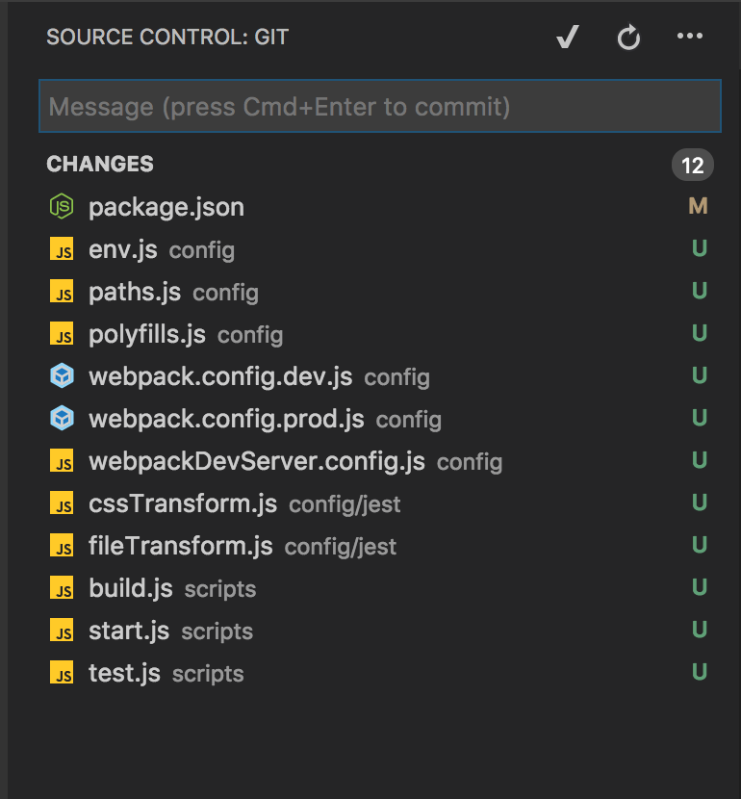

--Important files we need to work on are **webpack.config.dev** and **webpack.config.prod**

For bundling… also takes care of css files (import css…)

* In webpack.dev.config

Goto modules section and update it like this

test: /\.css$/,

use: [

require.resolve('style-loader'),

{

loader: require.resolve('css-loader'),

options: {

importLoaders: 1,

**modules: true,**

**localIdentName: ‘[name]__[local]__[hash:64:5]’** this will give local unique name to css class so that it wouldn’t share across the global space [name]=> this our css class name, [local]=>allows to css loader to assign to local basically (basically to scope it). [hash:64:5]=> to give unique hash code so that we do not overwrite.

},

},

* Do the same above step in prod

use: [

{

loader: require.resolve('css-loader'),

options: {

modules: true,

localIdentName: '[name]__[loal]__[hash:base64:5]',

importLoaders: 1,

minimize: true,

sourceMap: shouldUseSourceMap,

},

},

---------------------------------------------------------------------------------------------------------------------------------------------------------------------

After above change in configuration, import class from css file into the component, and use it as javascript object for example following is the code for css and followed by how to use in component

File: Person.css

.person{

color:’red’,

font-weight: ‘bold’

}

File: Display.js

Import cssclasses from ‘./Person.css’

….

… react return code

<div className={cssclasses.person}> asdfasd fasfdasdf</div>

NOTE FROM INSTRUCTOR

**CSS Modules** are a relatively new concept (you can dive super-deep into them here: <https://github.com/css-modules/css-modules>). With CSS modules, you can write normal CSS code and make sure, that it only applies to a given component.

It's not using magic for that, instead it'll simply **automatically generate unique CSS class names** for you. And by importing a JS object and assigning classes from there, you use these dynamically generated, unique names. So the imported JS object simply exposes some properties which hold the generated CSS class names as values.

**Example:**

**In Post.css File**

* .Post {
* color: red;
* }

**In Post Component File**

* import classes from './Post.css';
* const post = () => (
* <div className={classes.Post}>...</div>
* );

Here, classes.Post refers to an automatically generated Post property on the imported classes object. That property will in the end simply hold a value like Post__Post__ah5_1 .

So your .Post class was automatically transformed to a different class (Post__Post__ah5_1 ) which is unique across the application. You also can't use it accidentally in other components because you don't know the generated string! You can only access it through the classes object. And if you import the CSS file (in the same way) in another component, the classes object there will hold a Post property which yields a **different** (!) CSS class name. Hence it's scoped to a given component.

By the way, if you somehow also want to define a global (i.e. un-transformed) CSS class in such a .css file, you can prefix the selector with :global .

**Example:**

:global .Post { ... }

Now you can use className="Post" anywhere in your app and receive that styling.

Debugging

Custom error :

In REact 16 we can do Error boundary

**componentDidCatch**

This is a method which receives potential errors and some additional info passed by React, and executed whenever the component we wrap with errorBoundary throws an error

React dev tools

Key has to be in outer component (Errorboundary)

# **Error Boundaries**

In the past, JavaScript errors inside components used to corrupt React’s internal state and cause it to [emit](https://github.com/facebook/react/issues/4026) [cryptic](https://github.com/facebook/react/issues/6895) [errors](https://github.com/facebook/react/issues/8579) on next renders. These errors were always caused by an earlier error in the application code, but React did not provide a way to handle them gracefully in components, and could not recover from them.

## **Introducing Error Boundaries**

A JavaScript error in a part of the UI shouldn’t break the whole app. To solve this problem for React users, React 16 introduces a new concept of an “error boundary”.

Error boundaries are React components that catch JavaScript errors anywhere in their child component tree, log those errors, and display a fallback UI instead of the component tree that crashed. Error boundaries catch errors during rendering, in lifecycle methods, and in constructors of the whole tree below them.

**Note**

Error boundaries do not catch errors for:

* Event handlers ([learn more](https://reactjs.org/docs/error-boundaries.html#how-about-event-handlers))
* Asynchronous code (e.g. setTimeout or requestAnimationFrame callbacks)
* Server side rendering
* Errors thrown in the error boundary itself (rather than its children)

A class component becomes an error boundary if it defines a new lifecycle method called componentDidCatch(error, info):

class ErrorBoundary extends React.Component {  
 constructor(props) {  
 super(props);  
 this.state = { hasError: false };  
 }  
  
 componentDidCatch(error, info) {  
 // Display fallback UI  
 this.setState({ hasError: true });  
 // You can also log the error to an error reporting service  
 logErrorToMyService(error, info);  
 }  
  
 render() {  
 if (this.state.hasError) {  
 // You can render any custom fallback UI  
 return <h1>Something went wrong.</h1>;  
 }  
 return this.props.children;  
 }  
}

Then you can use it as a regular component:

<ErrorBoundary>  
 <MyWidget />  
</ErrorBoundary>

The componentDidCatch() method works like a JavaScript catch {} block, but for components. Only class components can be error boundaries. In practice, most of the time you’ll want to declare an error boundary component once and use it throughout your application.

Note that error boundaries only catch errors in the components below them in the tree. An error boundary can’t catch an error within itself. If an error boundary fails trying to render the error message, the error will propagate to the closest error boundary above it. This, too, is similar to how catch {} block works in JavaScript.

### **componentDidCatch Parameters**

error is an error that has been thrown.

info is an object with componentStack key. The property has information about component stack during thrown error.

//...  
componentDidCatch(error, info) {  
  
 /* Example stack information:  
 in ComponentThatThrows (created by App)  
 in ErrorBoundary (created by App)  
 in div (created by App)  
 in App  
 */  
 logComponentStackToMyService(info.componentStack);  
}  
  
//...

## **Live Demo**

Check out [this example of declaring and using an error boundary](https://codepen.io/gaearon/pen/wqvxGa?editors=0010) with [React 16](https://reactjs.org/blog/2017/09/26/react-v16.0.html).

## **Where to Place Error Boundaries**

The granularity of error boundaries is up to you. You may wrap top-level route components to display a “Something went wrong” message to the user, just like server-side frameworks often handle crashes. You may also wrap individual widgets in an error boundary to protect them from crashing the rest of the application.

## **New Behavior for Uncaught Errors**

This change has an important implication. As of React 16, errors that were not caught by any error boundary will result in unmounting of the whole React component tree.

We debated this decision, but in our experience it is worse to leave corrupted UI in place than to completely remove it. For example, in a product like Messenger leaving the broken UI visible could lead to somebody sending a message to the wrong person. Similarly, it is worse for a payments app to display a wrong amount than to render nothing.

This change means that as you migrate to React 16, you will likely uncover existing crashes in your application that have been unnoticed before. Adding error boundaries lets you provide better user experience when something goes wrong.

For example, Facebook Messenger wraps content of the sidebar, the info panel, the conversation log, and the message input into separate error boundaries. If some component in one of these UI areas crashes, the rest of them remain interactive.

We also encourage you to use JS error reporting services (or build your own) so that you can learn about unhandled exceptions as they happen in production, and fix them.

## **Component Stack Traces**

React 16 prints all errors that occurred during rendering to the console in development, even if the application accidentally swallows them. In addition to the error message and the JavaScript stack, it also provides component stack traces. Now you can see where exactly in the component tree the failure has happened:

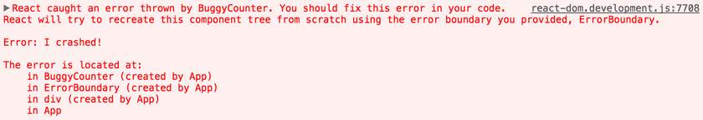

You can also see the filenames and line numbers in the component stack trace. This works by default in [Create React App](https://github.com/facebookincubator/create-react-app) projects:

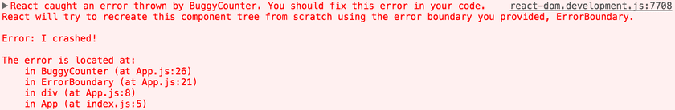

If you don’t use Create React App, you can add [this plugin](https://www.npmjs.com/package/babel-plugin-transform-react-jsx-source) manually to your Babel configuration. Note that it’s intended only for development and must be disabled in production.

**Note**

Component names displayed in the stack traces depend on the [Function.name](https://developer.mozilla.org/en-US/docs/Web/JavaScript/Reference/Global_Objects/Function/name) property. If you support older browsers and devices which may not yet provide this natively (e.g. IE 11), consider including a Function.name polyfill in your bundled application, such as [function.name-polyfill](https://github.com/JamesMGreene/Function.name). Alternatively, you may explicitly set the [displayName](https://reactjs.org/docs/react-component.html#displayname) property on all your components.

## **How About try/catch?**

try / catch is great but it only works for imperative code:

try {  
 showButton();  
} catch (error) {  
 // ...  
}

However, React components are declarative and specify *what* should be rendered:

<Button />

Error boundaries preserve the declarative nature of React, and behave as you would expect. For example, even if an error occurs in a componentDidUpdate hook caused by a setState somewhere deep in the tree, it will still correctly propagate to the closest error boundary.

## **How About Event Handlers?**

Error boundaries do not catch errors inside event handlers.

React doesn’t need error boundaries to recover from errors in event handlers. Unlike the render method and lifecycle hooks, the event handlers don’t happen during rendering. So if they throw, React still knows what to display on the screen.

If you need to catch an error inside event handler, use the regular JavaScript try / catchstatement:

class MyComponent extends React.Component {  
 constructor(props) {  
 super(props);  
 this.state = { error: null };  
 }  
  
 handleClick = () => {  
 try {  
 // Do something that could throw  
 } catch (error) {  
 this.setState({ error });  
 }  
 }  
  
 render() {  
 if (this.state.error) {  
 return <h1>Caught an error.</h1>  
 }  
 return <div onClick={this.handleClick}>Click Me</div>  
 }  
}

Note that the above example is demonstrating regular JavaScript behavior and doesn’t use error boundaries.

## **Naming Changes from React 15**

React 15 included a very limited support for error boundaries under a different method name: unstable_handleError. This method no longer works, and you will need to change it to componentDidCatch in your code starting from the first 16 beta release.

For this change, we’ve provided a [codemod](https://github.com/reactjs/react-codemod#error-boundaries) to automatically migrate your code.

**Component Deep Dive**

→ Custom classes start with capital letter.

→ function components for UI only (not for state management) components

→ Project can have multiple container components.

→ Use Class based components as little as possible.

Stateful components Vs Stateless components

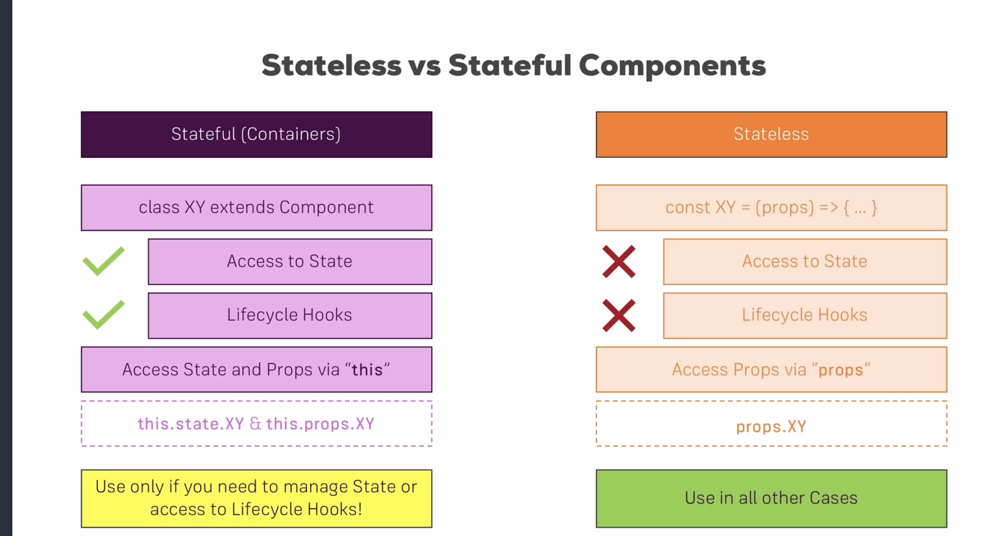

---> container has props too, so class components can access props using this.props like this.state

**Component Life Cycle**

1. Life cycle components are available in stateful components, not available in stateless components

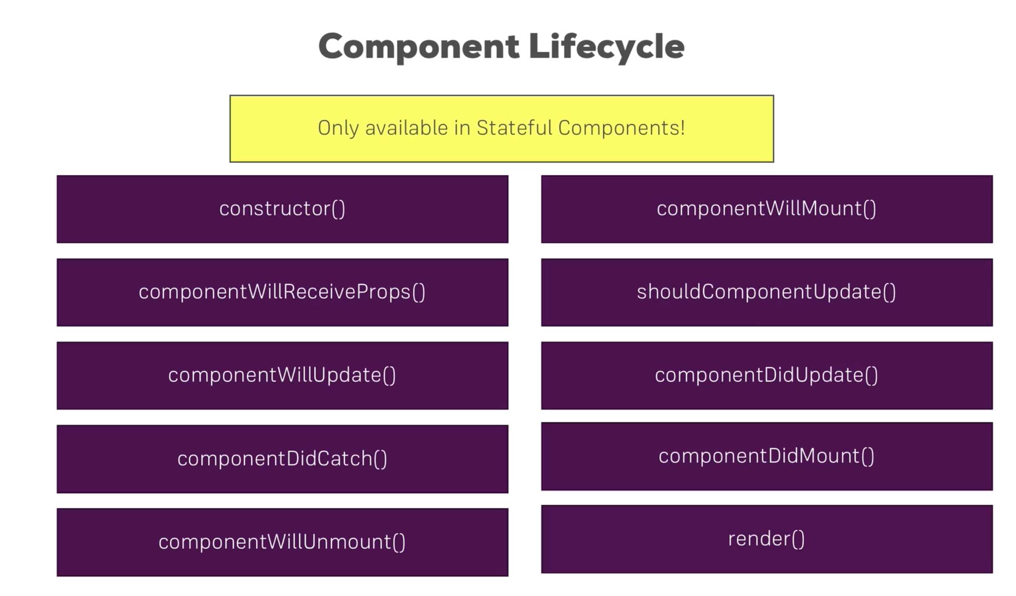

**Creation methods**

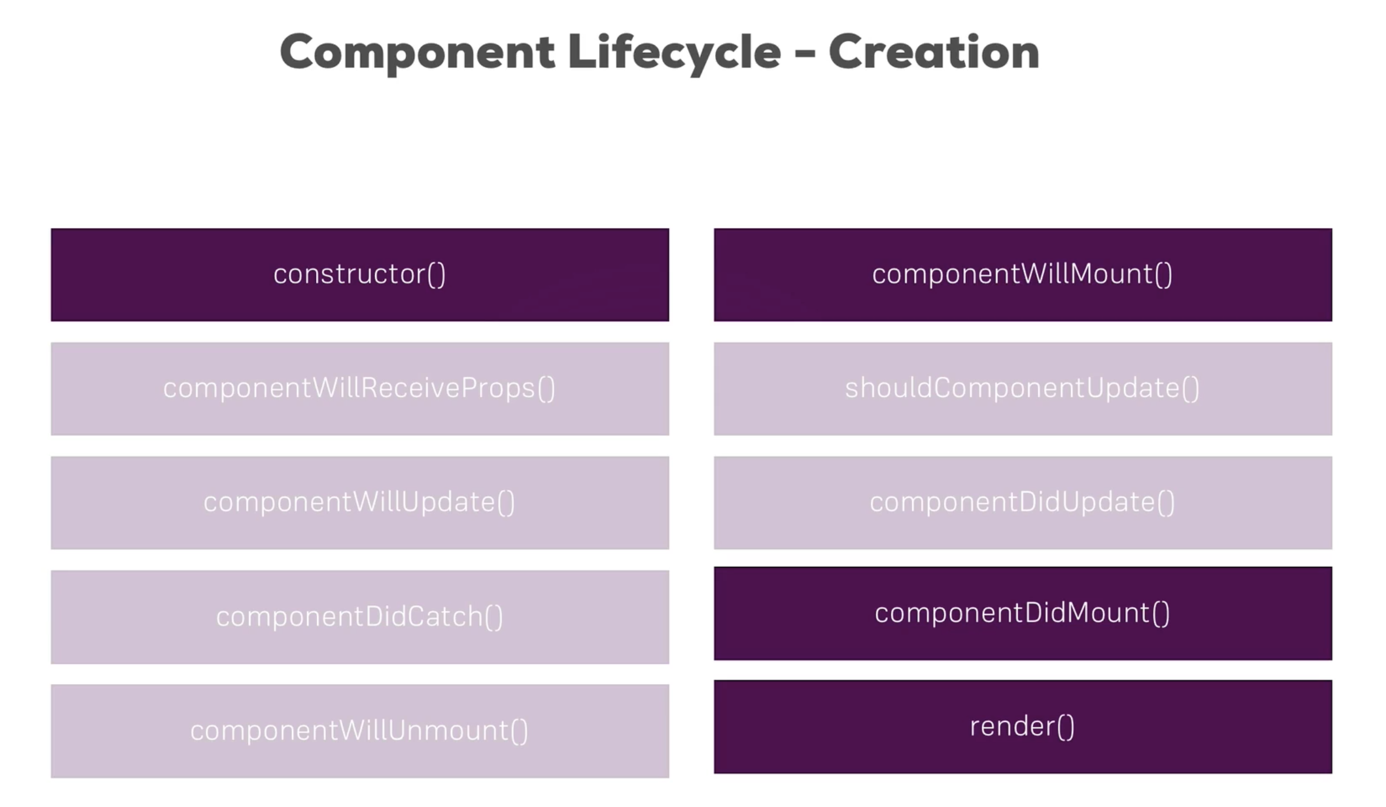

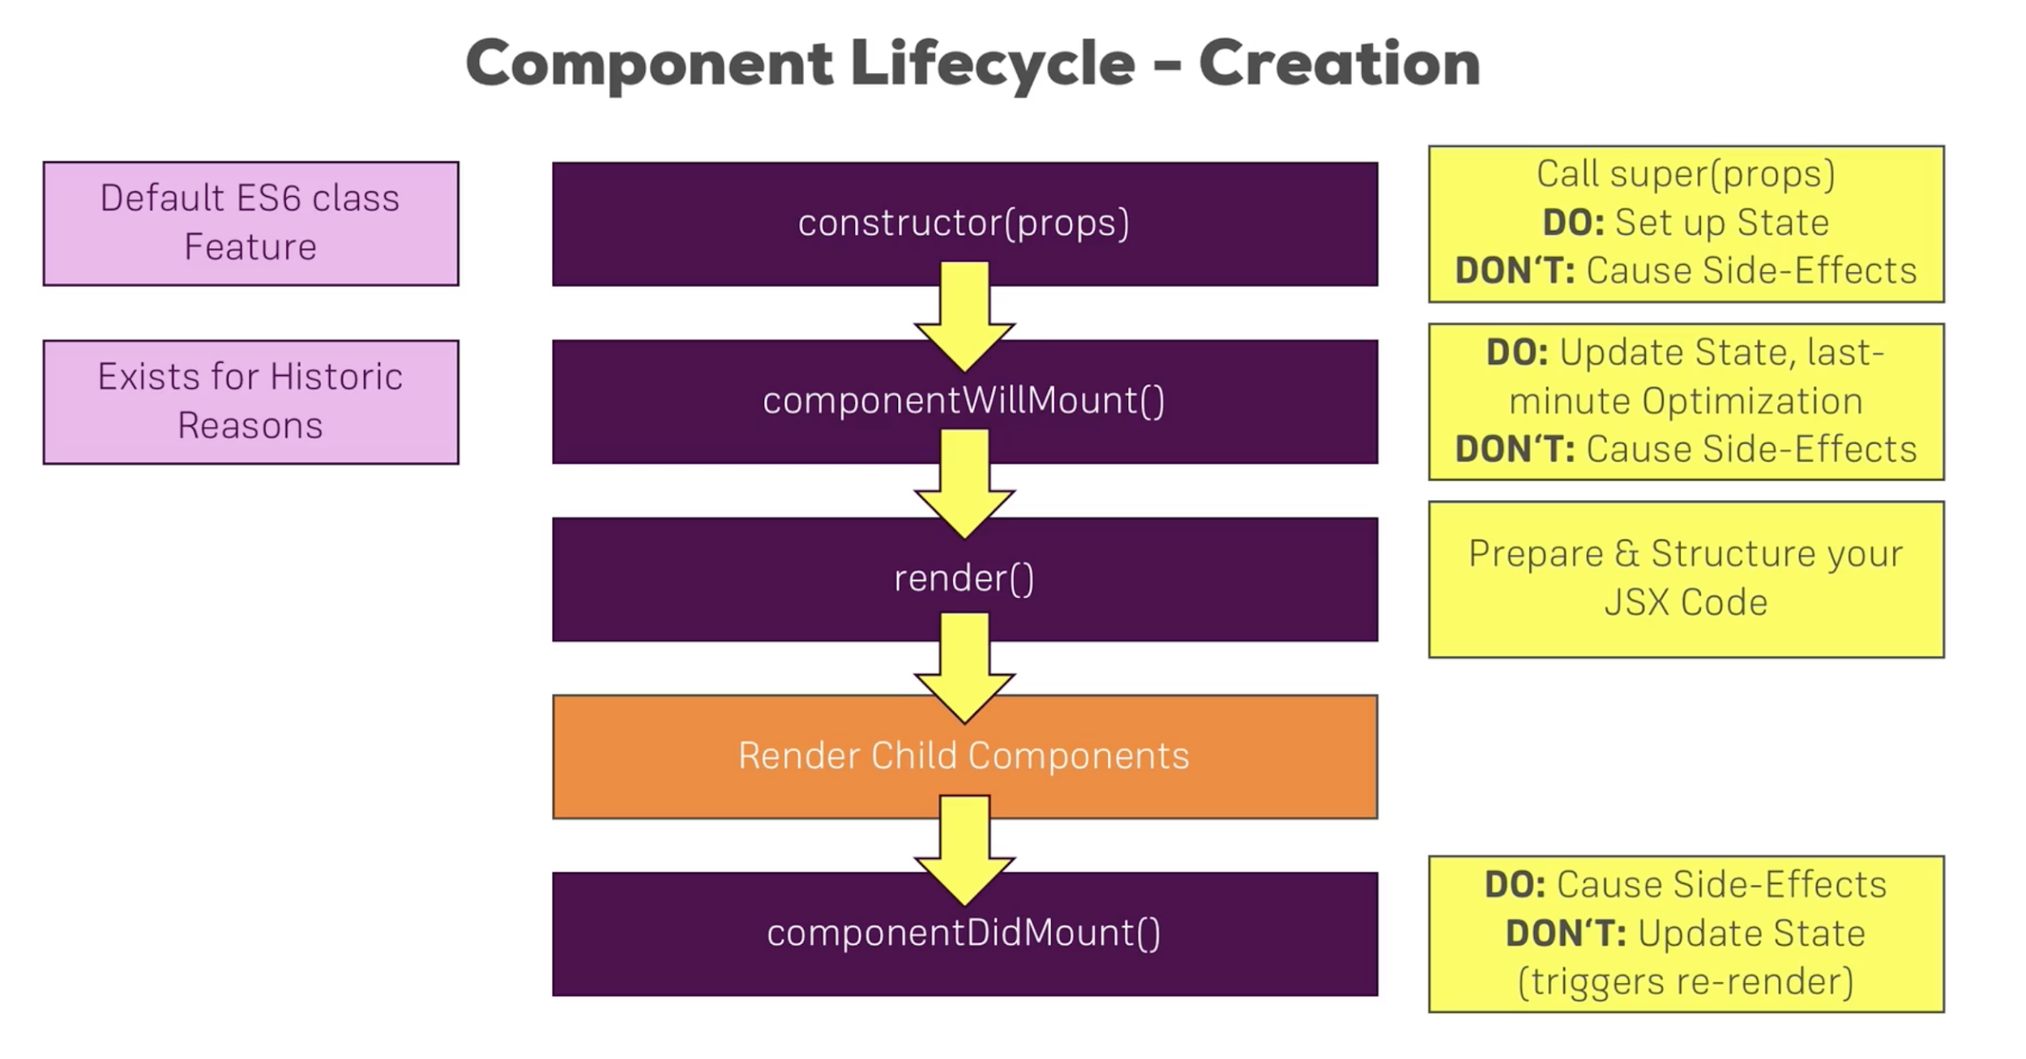

Constructor directly receives props property, so we can direct access it without referring to ‘**this**’. In all other places/methods we need to use ‘**this**’ in order to access container’s props

-? Is function components do have life cycle EVENTS ?

**CREATION LIFECYCLE**

1.constructor

2.componentWillMount

3.render

4.componentDidMount

**UPDATE by external LIFECYCLE**

---> updates can be by parent (props) or can be from internal (setState, update state)

BY PARENT

1.**componentWillReceiveProps**(nextProps): this method receives upcoming props, do: sync state to props

2.**shouldComponentUpdate(**nextProps, nextState): we get upcoming props and upcoming state. Props and state which trigger this update.

Don;t side business

Here we have ability to update or not. This is the only method returns a value (a bool). If we **return true the update continues**. **If we return false the update will not happen**

**3.componentWillUpdate(nextProps, nextState)** If above method returns true (i.e., continue with update) we will reach

Sysc state to props

4.**render** render JSX

5.**Update child components Props**

This is basically comparable to componentDidMount but for the udpates

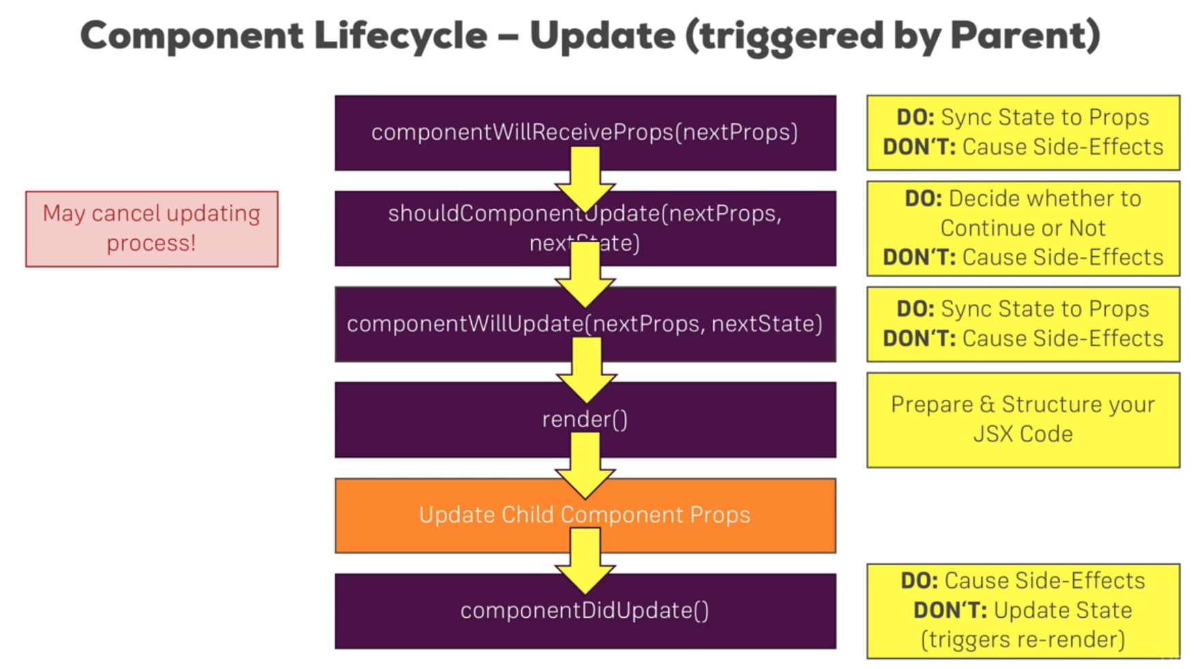

**UPDATE by internal LIFECYCLE (all most same, except no componentWillReceiveProps method)**

**Update by internally:** may be by setState

No will receive props.

1.**shouldComponentUpdate(**nextProps, nextState): we get upcoming props and upcoming state. Props and state which trigger this update.

Don;t side business

Here we have ability to update or not. This is the only method returns a value (a bool). If we **return true the update continues**. **If we return false the update will not happen**

2.**componentWillUpdate(nextProps, nextState)** If above method returns true (i.e., continue with update) we will reach

Sysc state to props

3.**render** render JSX

4.**Update child components Props**

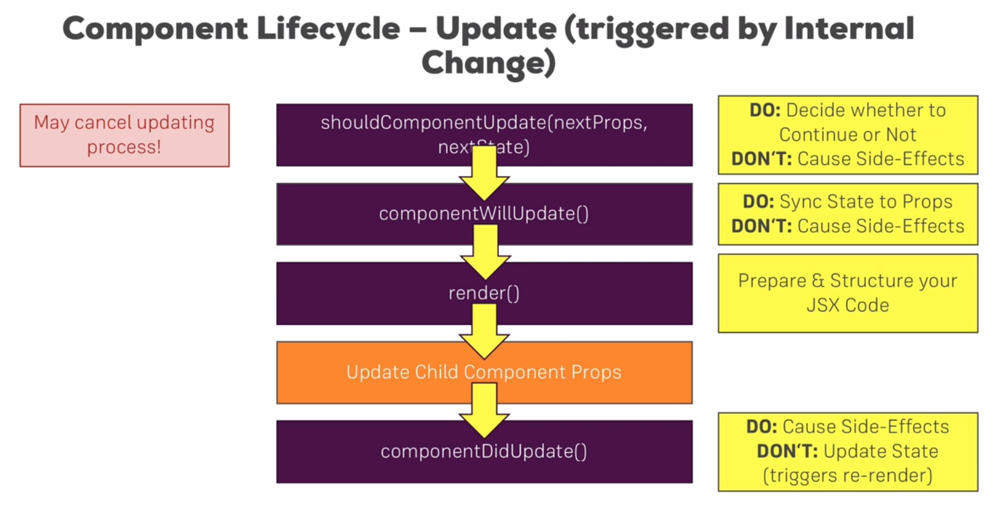

**→** React touches the Real DOM if and only if the render method execution results in any difference, So it has to execute all render code before deciding whether or not to render update/render/rerender the Real DOM. So for huge apps this will be a performance issue.

That is why we need to **shouldComponentUpdate** in order to tell React to move forward or not on executing rest of the lifeCycle hooks. If we return false in shouldComponentUpdate no further methods will be executed.

**PureComponent** for shallow compare; it is same as normal React Component but the **shouldComponentUpdate** is already built in implemented. It will go through all the properties of props and compare them with current version, and only continue if there are any differences. Same for state

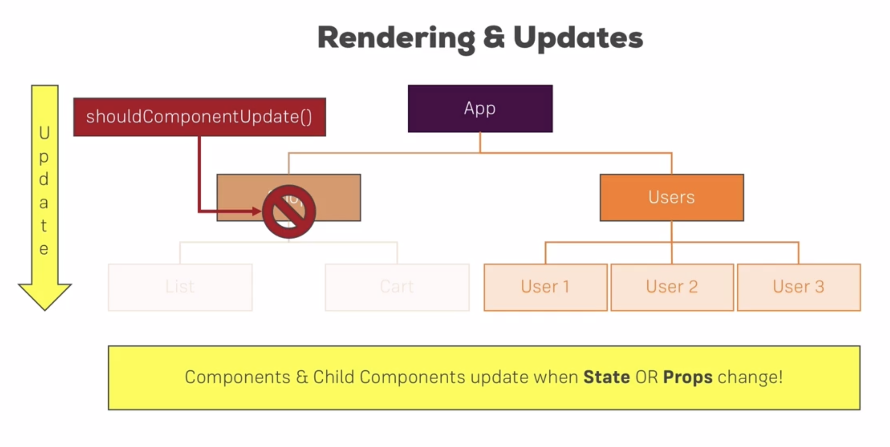

→ render() does not immediately updates DOM. It compares old virtual DOM and new virtual DOM if there are differences then it will update only the difference part of the DOM.

Even if shouldComponentUpdate() results true, but DOM has no change then render gets executed and gets new virtual DOM

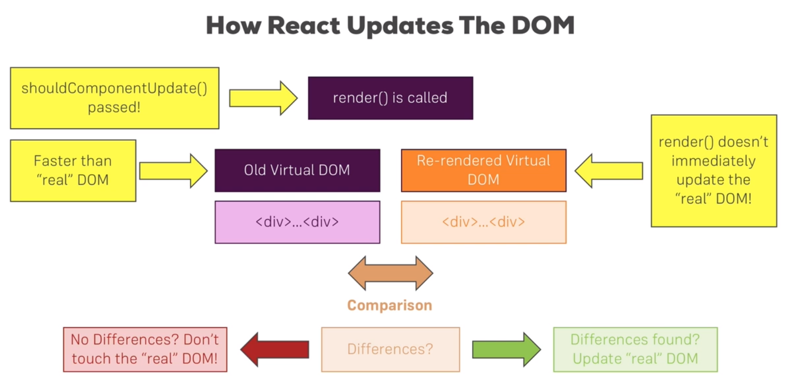

→ We can break the rule of wrapping elements in a wrapper element by returning array of elements with key value

→ or we can create an auxiliary (Higer Order Component hoc) component that basically creates elements as children elements

If your project uses **React 16.2**, you can now use a built-in "Aux" component - a so called **fragment**.

It's actually not called Aux but you simply use <> - an empty JSX tag.

So the following code

* <Aux>
* <h1>First Element</h1>
* <h1>Second Element</h1>
* </Aux>

becomes

* <>
* <h1>First Element</h1>
* <h1>Second Element</h1>
* </>

Behind the scenes, it does the same our Aux component did.

→

If a component returns JSX the start its name with Caps letter like **Person.js** if it does not return a JSX then start its name with lower letter.

---> sometimes we have state update that depends on old state update that becomes trivial…

The setState executes in asynchronous fashion, so setting values in this method is not so perfectly reliable as it can take time to finish, if we have multiple setstate methods being executed then we do not know which one finishes first and hence we do not confidently say a variable’s value or the commands being executed. So, the best practice to update state is to use following

this.setState( (prevState, prop) => {

Return {

stateProp1: newValue,

stateProp2: prevState.stateProp2 + 1

}

});

→ To make sure the props are properly assigned (type and value), like int prop should receive only int value, we use **prop-types** library to set up prop types, we can setup props at the end of the class (and before exporting that class) like following

Prop-types are used in classes not in functions ?

* We import prop-types then before we export our class we have to say *ourclass.propTypes = {*
  + *ourprop: PropTypes.string.isRequired*
* *}*

PersonClass.PropTypes = {

propOne: PropType.string,

propTwo: PropType.number

.

.

.

.

.

.

}

Available PropTypes

Section 7, Lecture 100

Source: <https://reactjs.org/docs/typechecking-with-proptypes.html>

* import PropTypes from 'prop-types';
* MyComponent.propTypes = {
* // You can declare that a prop is a specific JS primitive. By default, these
* // are all optional.
* optionalArray: PropTypes.array,
* optionalBool: PropTypes.bool,
* optionalFunc: PropTypes.func,
* optionalNumber: PropTypes.number,
* optionalObject: PropTypes.object,
* optionalString: PropTypes.string,
* optionalSymbol: PropTypes.symbol,
* // Anything that can be rendered: numbers, strings, elements or an array
* // (or fragment) containing these types.
* optionalNode: PropTypes.node,
* // A React element.
* optionalElement: PropTypes.element,
* // You can also declare that a prop is an instance of a class. This uses
* // JS's instanceof operator.
* optionalMessage: PropTypes.instanceOf(Message),
* // You can ensure that your prop is limited to specific values by treating
* // it as an enum.
* optionalEnum: PropTypes.oneOf(['News', 'Photos']),
* // An object that could be one of many types
* optionalUnion: PropTypes.oneOfType([
* PropTypes.string,
* PropTypes.number,
* PropTypes.instanceOf(Message)
* ]),
* // An array of a certain type
* optionalArrayOf: PropTypes.arrayOf(PropTypes.number),
* // An object with property values of a certain type
* optionalObjectOf: PropTypes.objectOf(PropTypes.number),
* // An object taking on a particular shape
* optionalObjectWithShape: PropTypes.shape({
* color: PropTypes.string,
* fontSize: PropTypes.number
* }),
* // You can chain any of the above with `isRequired` to make sure a warning
* // is shown if the prop isn't provided.
* requiredFunc: PropTypes.func.isRequired,
* // A value of any data type
* requiredAny: PropTypes.any.isRequired,
* // You can also specify a custom validator. It should return an Error
* // object if the validation fails. Don't `console.warn` or throw, as this
* // won't work inside `oneOfType`.
* customProp: function(props, propName, componentName) {
* if (!/matchme/.test(props[propName])) {
* return new Error(
* 'Invalid prop `' + propName + '` supplied to' +
* ' `' + componentName + '`. Validation failed.'
* );
* }
* },
* // You can also supply a custom validator to `arrayOf` and `objectOf`.
* // It should return an Error object if the validation fails. The validator
* // will be called for each key in the array or object. The first two
* // arguments of the validator are the array or object itself, and the
* // current item's key.
* customArrayProp: PropTypes.arrayOf(function(propValue, key, componentName, location, propFullName) {
* if (!/matchme/.test(propValue[key])) {
* return new Error(
* 'Invalid prop `' + propFullName + '` supplied to' +
* ' `' + componentName + '`. Validation failed.'
* );
* }
* })
* };

#### Requiring Single Child

With PropTypes.element you can specify that only a single child can be passed to a component as children.

* import PropTypes from 'prop-types';
* class MyComponent extends React.Component {
* render() {
* // This must be exactly one element or it will warn.
* const children = this.props.children;
* return (
* <div>
* {children}
* </div>
* );
* }
* }
* MyComponent.propTypes = {
* children: PropTypes.element.isRequired
* };

#### Default Prop Values

You can define default values for your props by assigning to the special defaultProps property:

* class Greeting extends React.Component {
* render() {
* return (
* <h1>Hello, {this.props.name}</h1>
* );
* }
* }
* // Specifies the default values for props:
* Greeting.defaultProps = {
* name: 'Stranger'
* };
* // Renders "Hello, Stranger":
* ReactDOM.render(
* <Greeting />,
* document.getElementById('example')
* );

The defaultProps will be used to ensure that this.props.name will have a value if it was not specified by the parent component. The propTypes typechecking happens after defaultProps are resolved, so typechecking will also apply to the defaultProps.

→ Focus: may be after componentDidMount()

Use property called **ref** , key. ref takes a function that takes one input and that input is the element itself (the element in which we are adding ref to); NOTE: refs are available in stateful components only.

Maybe we can think ref as ref for and element ?

Remember did mount method executes after render so if you add a dynamic property in rendor, you can access it in did mount method.

DO NOT USE REF FOR STYLING OR ANY OTHER STUFF EXCEPT FOCUS OR MEDIA PLAYBACK

New 16.3

Refs: in constructor use **React.createRef** , use **current**

16.3 supports refs from outside (in other word, ref forwarded) of the component.

Context API : for sometime global State, like authenticated or theme color….

**React.createContext()**  this works using providers and consumers

The context’s Provider component usually wrapper around the component collection where we want to use context value. The context gets and sets a value property, where usually we might want to add state property value,

The context’s Consumer takes method and executes it.

In 16.3 three methods are discouraged to be used those are

X componentWillMount X

X componentWillReceive X

X componentWillUpdate X

The reason behind discouragement is they often used incorrectly. 16.3 has two new methods

---> getDerivedStateFromProps(nextProps, prevState); this gets executed whenever props get updated. This is static method; and is executed before render or mounting

→ getSnapshBeforeUpdate(); gets dom right before it gets changed; before componentDidUpdate: example use is save scroll position in this method and go to saved scroll position when componentDidUpdate gets executed

### **Course Content**

Search:

Section: 1**11 / 11**

Getting Started

Section: 2**13 / 13**

Refreshing Next Generation JavaScript (Optional)

Section: 3**24** / 25

Understanding the Base Features & Syntax

Section: 4**11** / 12

Working with Lists and Conditionals

Section: 5**11 / 11**

Styling React Components & Elements

Section: 6**7 / 7**

Debugging React Apps

Section: 7**29 / 29**

Diving Deeper into Components & React Internals

Section: 8**40 / 40**

A Real App: The Burger Builder (Basic Version)

Section: 9**18 / 18**

Reaching out to the Web (Http / Ajax)

Section: 10**9 / 9**

Burger Builder Project: Accessing a Server

Section: 11**32** / 33

Multi-Page-Feeling in a Single-Page-App: Routing

Section: 12**14 / 14**

Adding Routing to our Burger Project

Section: 13**17 / 17**

Forms and Form Validation

Section: 14**21** / 23

Redux

Section: 15**3** / 10

Adding Redux to our Project

Section: 160 / 16

Redux Advanced

Section: 170 / 22

Redux Advanced: Burger Project

Section: 180 / 22

Adding Authentication to our Burger Project

Section: 190 / 9

Improving our Burger Project

Section: 200 / 12

Testing

Section: 210 / 6

Deploying the App to the Web

Section: 220 / 20

Bonus: Working with Webpack

Section: 230 / 10

Bonus: Next.js

Section: 240 / 16

Bonus: Animations in React Apps

Section: 250 / 13

Bonus: A Brief Introduction to Redux Saga

Section: 260 / 1

Bonus: Building the Burger CSS

Section: 270 / 9

Next Steps and Course Roundup

We're testing translated captions for this lectureGive your opinion

Useful Resources & Links

Section 7, Lecture 106

* State & Lifecycle: <https://reactjs.org/docs/state-and-lifecycle.html>
* PropTypes: <https://reactjs.org/docs/typechecking-with-proptypes.html>
* Higher Order Components: <https://reactjs.org/docs/higher-order-components.html>
* Refs: <https://reactjs.org/docs/refs-and-the-dom.html>

Resources for this lecture

* cmp-deep-dive--01-after-cmp-split.zip
* cmp-deep-dive--02-added-lifecycle.zip
* cmp-deep-dive--03-should-component-update.zip

Show more (5)

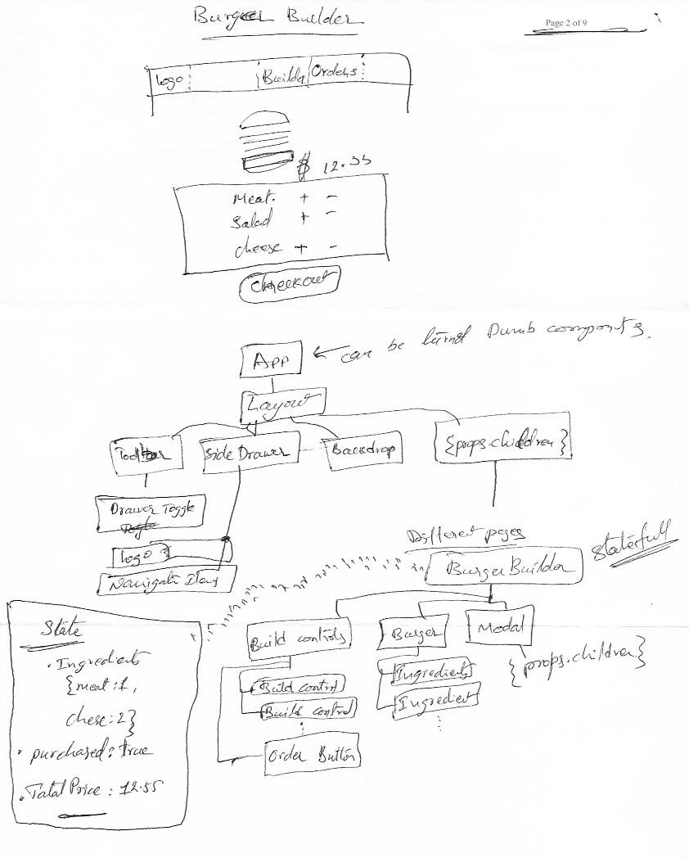

------> If we need to access state in setState, we should use following way

this.setState((prevState) => {

return {statevariable: !prevState.statevariablevalue}

})

We above stuff because this.setState is asynchronus… and to update current state depanding on old state

→ ComponentDidMount and ComponentDidUpdate Cycle hooks are important for causing side effect (http)

# Reaching Out to the Web Http/Ajax

147, 148 Lecture

Website: jsonplaceholder.typicode.com

2 options

1. xmlHttp: Cumbersome
2. Axios: thirdpart javascript library, no connection to react

Where to call http ? **componentDidMount**

But for updating state, this flicycle hook is not good, as it rerenders; Well some cases we want to do exactly this.

**AXIOS**:

Get:

**axios.get(**‘url’, <configuration>**).then(**response => {asdfasdfs}**);**

**→** this.setState() re-executes componentDidUpdate as of part of life cycle hooks execution.

Axios.interceptors, return requestconfig (lecture 159); syntax axios.interceptors.request.use

Interceptor can take another param function with error param, but we need to return it back with promise rejuction;

axios.default.baseURL

axios.default.headers.common[‘Authorization’] = ‘AUTH TOCKEN’;

axios.default.headers.post[‘ContentType’] = ‘application/json’;

Routing

Not from React

Install

We can next rout inline ?

In <Route tag, the component value should be reference to a function or a class we want to use.

*<Route path=”/” exact component={Posts} />*

We can also use render property for loading a JSX, but it is suggested to you this feature for small elements, like tooltip … example

<Route path=”/” exact render={() => <p>OK</p>}

Above code reloads whole page, which we may not want in SPA.

Use Link for anchor tag for asynchromous:

*<Link to =”/”>link text</Link>*

*<Link to={{*

*pathname: ‘/new-post’,*

*hash: ‘#submit’,*

*search:’?quick-submit=true’*

*}} >link text 2</Link>*

When we do not use ‘exact’ in Link component, it will look for satisfactory url, for example;

localhost:123/new-post and localhost:123/new-post/33 will show the same.

-but when we use ‘exact’ in Link component; localhost:123/new-post and localhost:123/new-post/33 are not same.

-Use ‘withRouter’ (this is an higher order component) component from ‘react-router-dom’ for forwarding props of router to component tree;

For ex: if you do not use withRouter on a component which loads child components using router, and these child router do not get props of parent’s router props. **Called router aware**

Absolute: add it to domain

→ Use ‘NavLink’ for extra props like css class assignment.

→ For dynamic Route, use ‘:variable’ in Route component’s path property,

→ in Link component’s ‘to’ property might not work if do not include ‘/’ in its value

**Switch:** component from ‘react-router-dom’ helps render only one route from a given set of routes.

→ Route does not unmount and remount component each time route renders the same control, So it is our responsibility to respond based on url.

→ Redirect: <Redirect from="/" to="/post" />

Note: if ‘Redirect’ is used in JSX outside of Switch, we have to have ‘to’ property only, we can not use from

→ Redirect will replace content, so as per browser’s history, Redirect is not really a redirect. When you change content using Redirect and click on browser back button, it does not work as expected, but ‘**this.props.history.push(‘’)**’ does. Also ‘**this.props.history.replace(‘’) ~= Redirect**’ does same Redirect.

# Lazy Loading or Code splitting:

Rendering only the code necessary, not rendering everything upfront. Load a component code only when needed.

→ this technic heavily depends on webpack config

→ when we say import ….. For importing component then webpack includes that component in the global bundle and that is how it is rendered by default, but the lazy loading concept is opposite to this, we should load component only we need it (in other words lmport component only when needed).

→ looks like there are 2 ways to set up lazy loading, 1 using create-react-app or 2.webpack configuration

---> on production

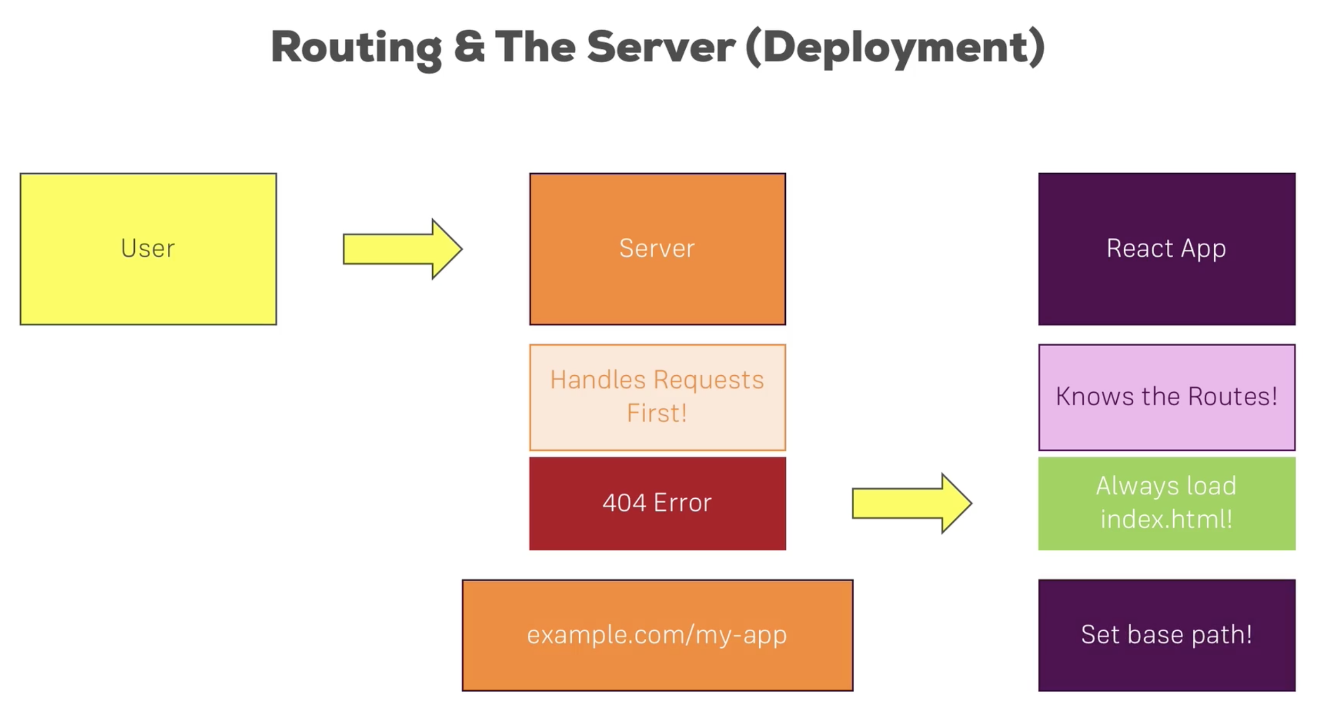

<https://reacttraining.com/react-router/web/guides/philosophy>

→ Use WithRouter helper method when we render a component using render property of Route component and want to redirect...

# Forms & Validation

Manual

REDUX

(a stand alone package, to connect redux with react we neet install react-redux)

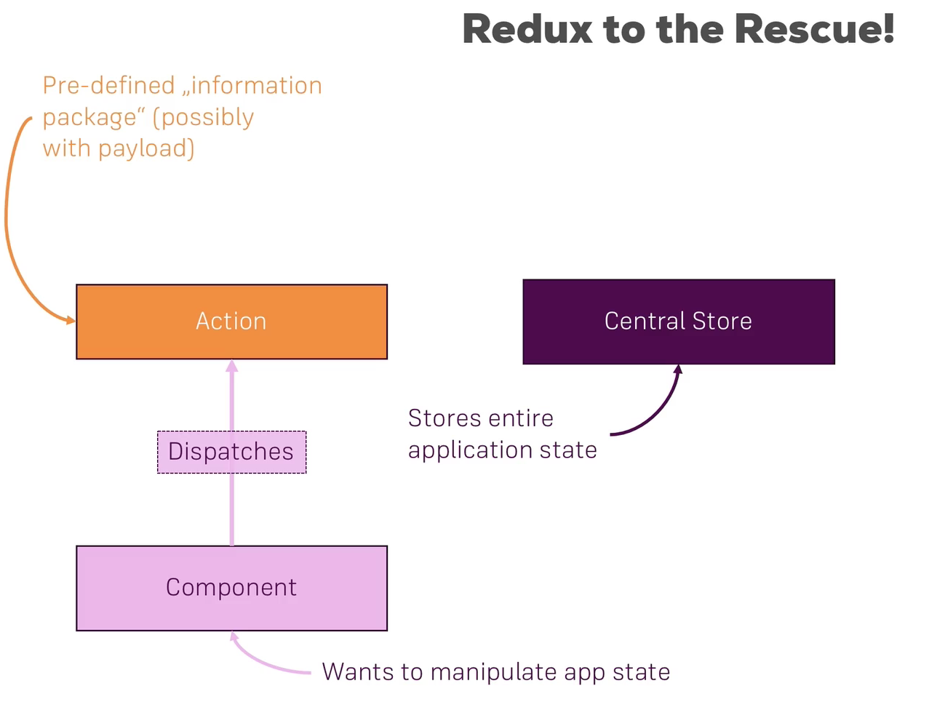

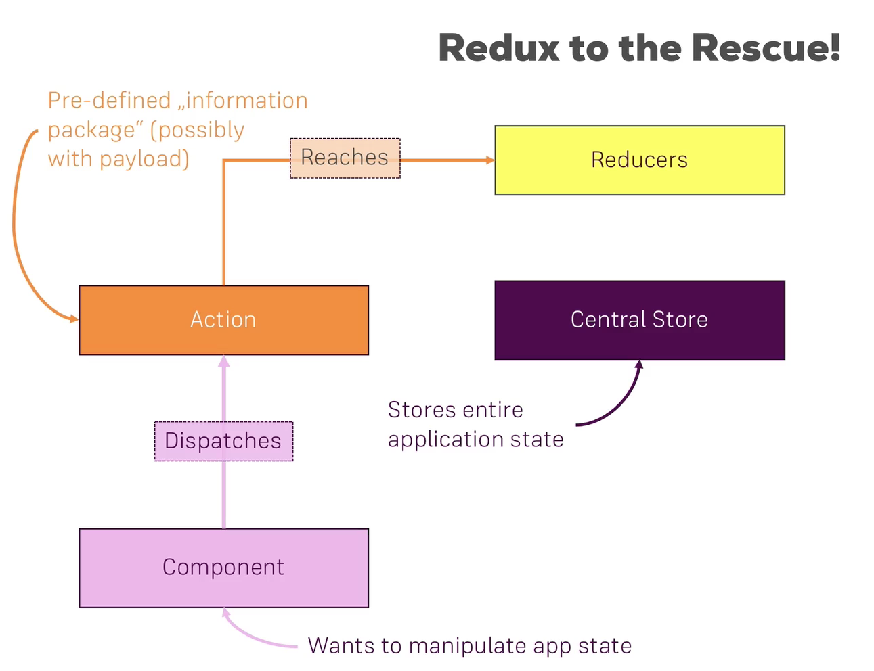

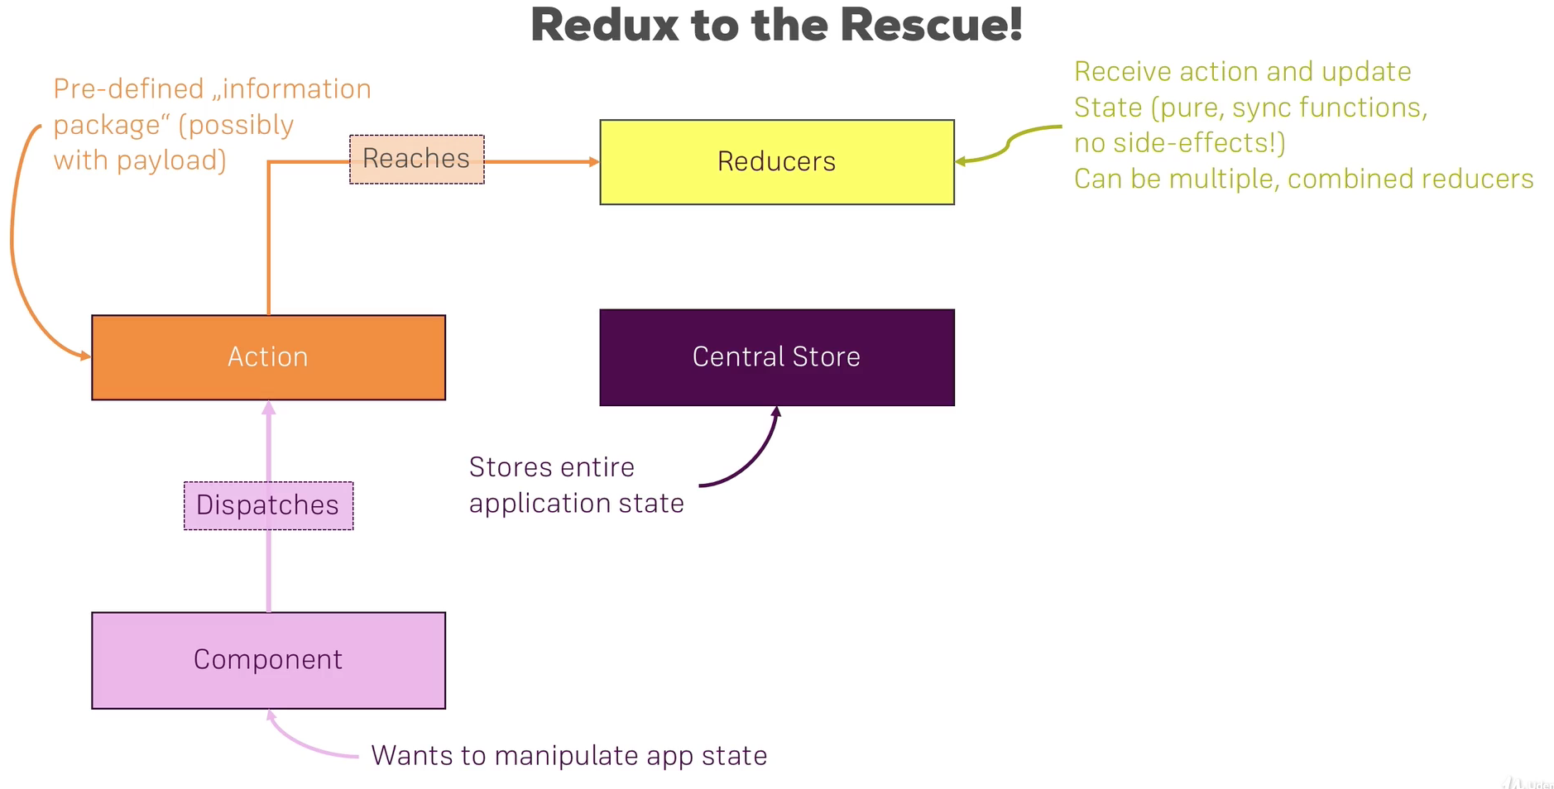

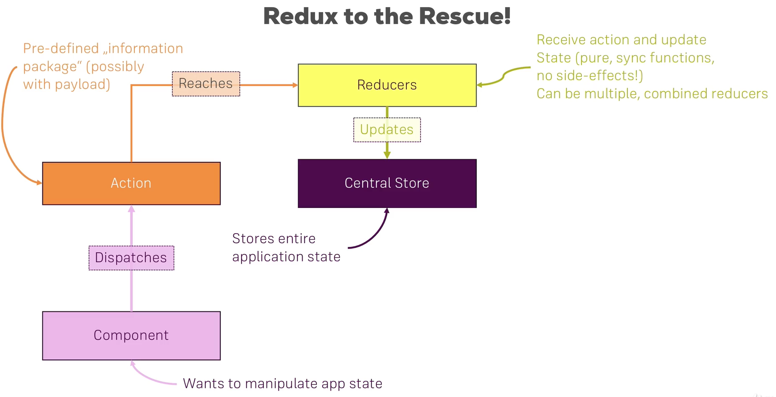

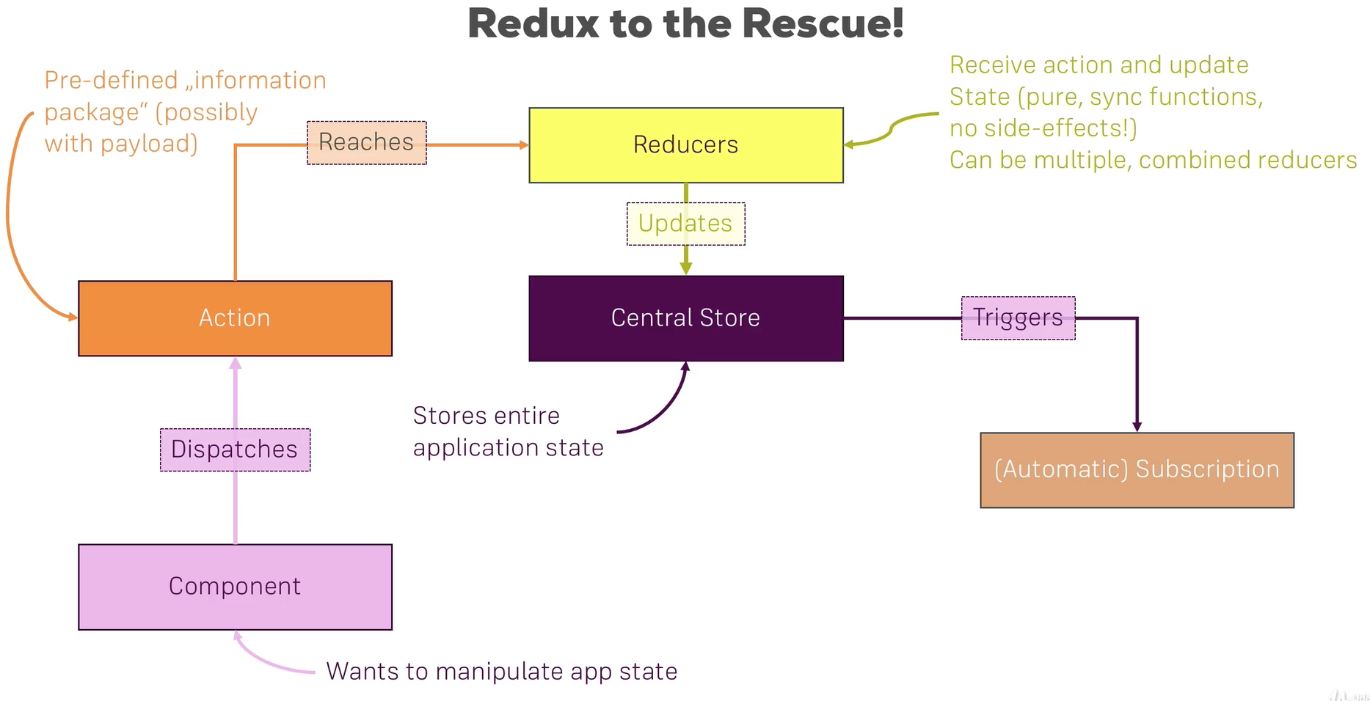

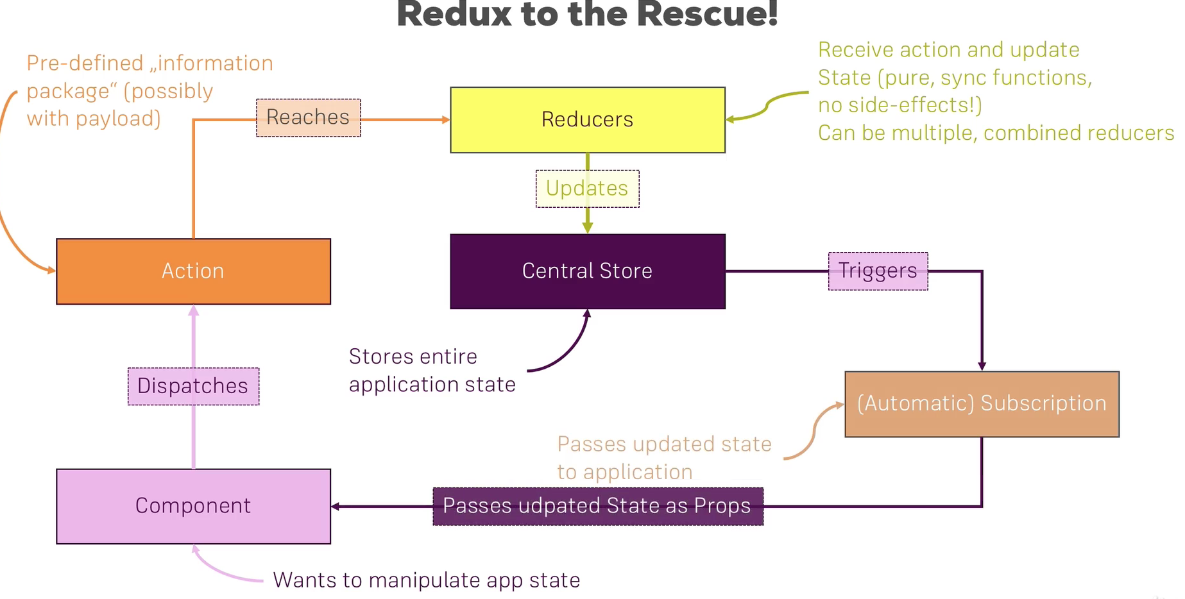

→ Store: just Store, not even Created, because we need Reducer to create a store

→ Reducer: function gets two arguments; 1 current state, 2 action. It returns one thing that is updated state (could just return same state) =>

So, we can create a store using Reducer, first create Reducer function then pass it as parameter to createStore. Now to get value just call ‘getState’ on the store.

→ Dispatching Action: takes a javascript object where ‘type’ is mandatory property, which says what kind of action needs to be performed on state.

Note: do not mutate state directly;

**const rootReducer = function(state = initialState, action){**

**if(action.type === 'INC_COUNTER'){**

**return {**

**...state,**

**counter: state.counter + 1**

**};**

**};**

**if(action.type === 'ADD_COUNTER'){**

**return {**

**...state,**

**counter: state.counter + action.value**

**};**

**};**

**}**

**const store = redux.createStore(rootReducer );**

**console.log(store.getState());**

**store.dispatch({**

**type:"INC_COUNTER" → first argument has to be ‘type’**

**});**

**store.dispatch({**

**type:"ADD_COUNTER",**

**value: 10 → after first argument all other can be anything**

**});**

→ Subscription

**//Subscription**

**store.subscribe(() => {**

**console.log('[subscription]', store.getState());**

**});**

**store.dispatch({**

**type:"ADD_COUNTER",**

**value: 10**

**});**

**store.dispatch({**

**type:"ADD_COUNTER",**

**value: 3**

**});**

Immutable Update Patterns

Section 14, Lecture 251

Immutable Update Patterns on reduxjs.org: <http://redux.js.org/docs/recipes/reducers/ImmutableUpdatePatterns.html>

#### Updating Nested Objects

The key to updating nested data is **that *every* level of nesting must be copied and updated appropriately**. This is often a difficult concept for those learning Redux, and there are some specific problems that frequently occur when trying to update nested objects. These lead to accidental direct mutation, and should be avoided.

##### Common Mistake #1: New variables that point to the same objects

Defining a new variable does *not* create a new actual object - it only creates another reference to the same object. An example of this error would be:

* function updateNestedState(state, action) {
* let nestedState = state.nestedState;
* // ERROR: this directly modifies the existing object reference - don't do this!
* nestedState.nestedField = action.data;
* return {
* ...state,
* nestedState
* };
* }

This function does correctly return a shallow copy of the top-level state object, but because the nestedState variable was still pointing at the existing object, the state was directly mutated.

##### Common Mistake #2: Only making a shallow copy of one level

Another common version of this error looks like this:

* function updateNestedState(state, action) {
* // Problem: this only does a shallow copy!
* let newState = {...state};
* // ERROR: nestedState is still the same object!
* newState.nestedState.nestedField = action.data;
* return newState;
* }

Doing a shallow copy of the top level is *not* sufficient - the nestedState object should be copied as well.

##### Correct Approach: Copying All Levels of Nested Data

Unfortunately, the process of correctly applying immutable updates to deeply nested state can easily become verbose and hard to read. Here's what an example of updating state.first.second[someId].fourth might look like:

* function updateVeryNestedField(state, action) {
* return {
* ...state,
* first : {
* ...state.first,
* second : {
* ...state.first.second,
* [action.someId] : {
* ...state.first.second[action.someId],
* fourth : action.someValue
* }
* }
* }
* }
* }

Obviously, each layer of nesting makes this harder to read, and gives more chances to make mistakes. This is one of several reasons why you are encouraged to keep your state flattened, and compose reducers as much as possible.

#### Inserting and Removing Items in Arrays

Normally, a Javascript array's contents are modified using mutative functions like push, unshift, and splice. Since we don't want to mutate state directly in reducers, those should normally be avoided. Because of that, you might see "insert" or "remove" behavior written like this:

* function insertItem(array, action) {
* return [
* ...array.slice(0, action.index),
* action.item,
* ...array.slice(action.index)
* ]
* }
* function removeItem(array, action) {
* return [
* ...array.slice(0, action.index),
* ...array.slice(action.index + 1)
* ];
* }

However, remember that the key is that the *original in-memory reference* is not modified. **As long as we make a copy first, we can safely mutate the copy**. Note that this is true for both arrays and objects, but nested values still must be updated using the same rules.

This means that we could also write the insert and remove functions like this:

* function insertItem(array, action) {
* let newArray = array.slice();
* newArray.splice(action.index, 0, action.item);
* return newArray;
* }
* function removeItem(array, action) {
* let newArray = array.slice();
* newArray.splice(action.index, 1);
* return newArray;
* }

The remove function could also be implemented as:

* function removeItem(array, action) {
* return array.filter( (item, index) => index !== action.index);
* }

#### Updating an Item in an Array

Updating one item in an array can be accomplished by using Array.map, returning a new value for the item we want to update, and returning the existing values for all other items:

* function updateObjectInArray(array, action) {
* return array.map( (item, index) => {
* if(index !== action.index) {
* // This isn't the item we care about - keep it as-is
* return item;
* }
* // Otherwise, this is the one we want - return an updated value
* return {
* ...item,
* ...action.item
* };
* });
* }

#### Immutable Update Utility Libraries

Because writing immutable update code can become tedious, there are a number of utility libraries that try to abstract out the process. These libraries vary in APIs and usage, but all try to provide a shorter and more succinct way of writing these updates. Some, like [dot-prop-immutable](https://github.com/debitoor/dot-prop-immutable), take string paths for commands:

* state = dotProp.set(state, `todos.${index}.complete`, true)

Others, like [immutability-helper](https://github.com/kolodny/immutability-helper) (a fork of the now-deprecated React Immutability Helpers addon), use nested values and helper functions:

* var collection = [1, 2, {a: [12, 17, 15]}];
* var newCollection = update(collection, {2: {a: {$splice: [[1, 1, 13, 14]]}}});

They can provide a useful alternative to writing manual immutable update logic.

[Immutable Data#Immutable Update Utilities](https://github.com/markerikson/redux-ecosystem-links/blob/master/immutable-data.md#immutable-update-utilities) section of the [Redux Addons Catalog](https://github.com/markerikson/redux-ecosystem-links).

===============================================================================================

Outsource actions indexes to constants

→ We do not see error, when we not handle dispatch in reducer.

→ use ‘combineReducers’ helper module from ‘redux’ package to combine multiple reducers.

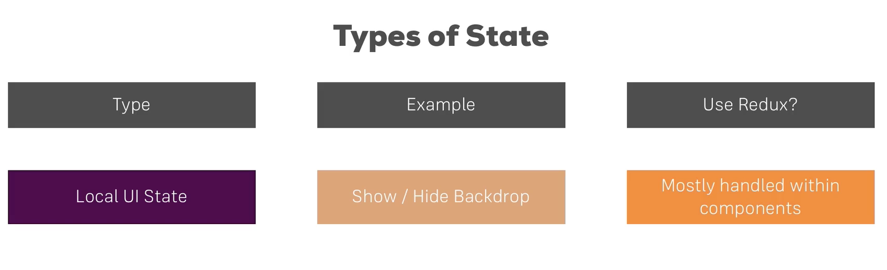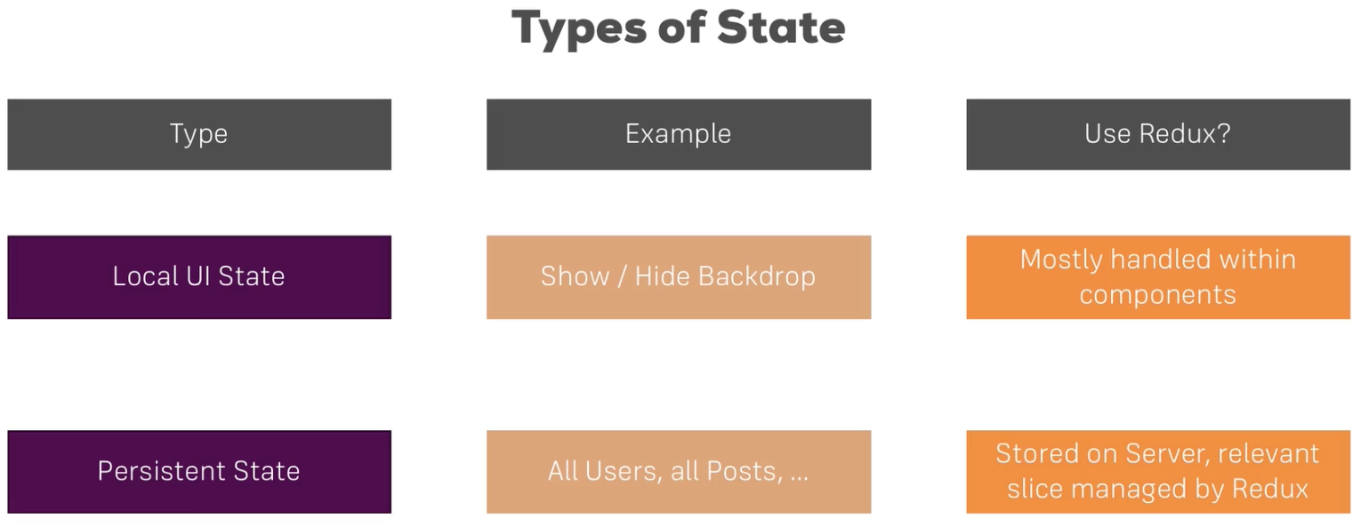

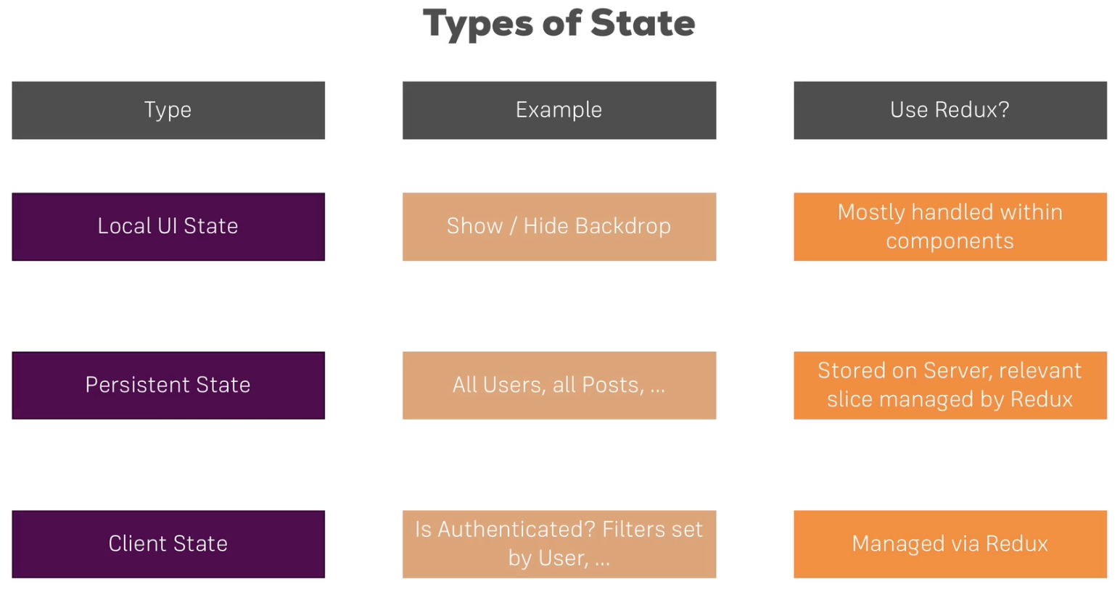

Reducer

import * as actionTypes from './actions';

const initialState = {

ingredients: {

salad:0,

bacon:0,

cheese:0,

meat:0

},

totalPrice: 4,

//purchasable: false,

//purchasing: false

};

const INGREDIENT_PRICES = {

salad: 0.5,

cheese: 0.4,

meat: 1.3,

bacon: 0.7

};

const reducer = (state = initialState, action) => {

switch(action.type){

case(actionTypes.ADD_INGREDIENT):

return {

...state,

ingredients: {

...state.ingredients,

[action.ingredientName]:state.ingredients[action.ingredientName] + 1

},

totalPrice: state.totalPrice + INGREDIENT_PRICES[action.ingredientName],

//purchasable: true

}

case(actionTypes.REMOVE_INGREDIENT):

return {

...state,

ingredients:{

...state.ingredients,

[action.ingredientName]:state.ingredients[action.ingredientName] - 1

},

totalPrice: state.totalPrice - INGREDIENT_PRICES[action.ingredientName],

//purchasable: state.totalPrice > 0

}

default:

return state;

}

}

export default reducer;

Index

import { Provider } from 'react-redux';

import { createStore } from 'redux';

import './index.css';

import App from './App';

import registerServiceWorker from './registerServiceWorker';

import reducer from './store/reducer';

const reduxStore = createStore(reducer);

const app = (

<Provider store={reduxStore}>

<BrowserRouter>

<App/>

</BrowserRouter>

</Provider>

);

ReactDOM.render(app, document.getElementById('root'));

Components

const mapStateToProps = (state) => {

return{

ings: state.ingredients,

ttlPrice: state.totalPrice,

//isPurchasable: state.purchasable,

//isPurchasing: state.purchasing

}

};

const mapDispatchToProps = (dispatch) =>{

return{

addIngredient: (ingredientType) => dispatch({ type: actionTypes.ADD_INGREDIENT, ingredientName: ingredientType}),

deleteIngredient: (ingredientType) => dispatch({ type: actionTypes.REMOVE_INGREDIENT, ingredientName: ingredientType})

}

};

export default connect(mapStateToProps, mapDispatchToProps)(withErrorHandler(BurgerBuilder, axios));

We can add middle wear

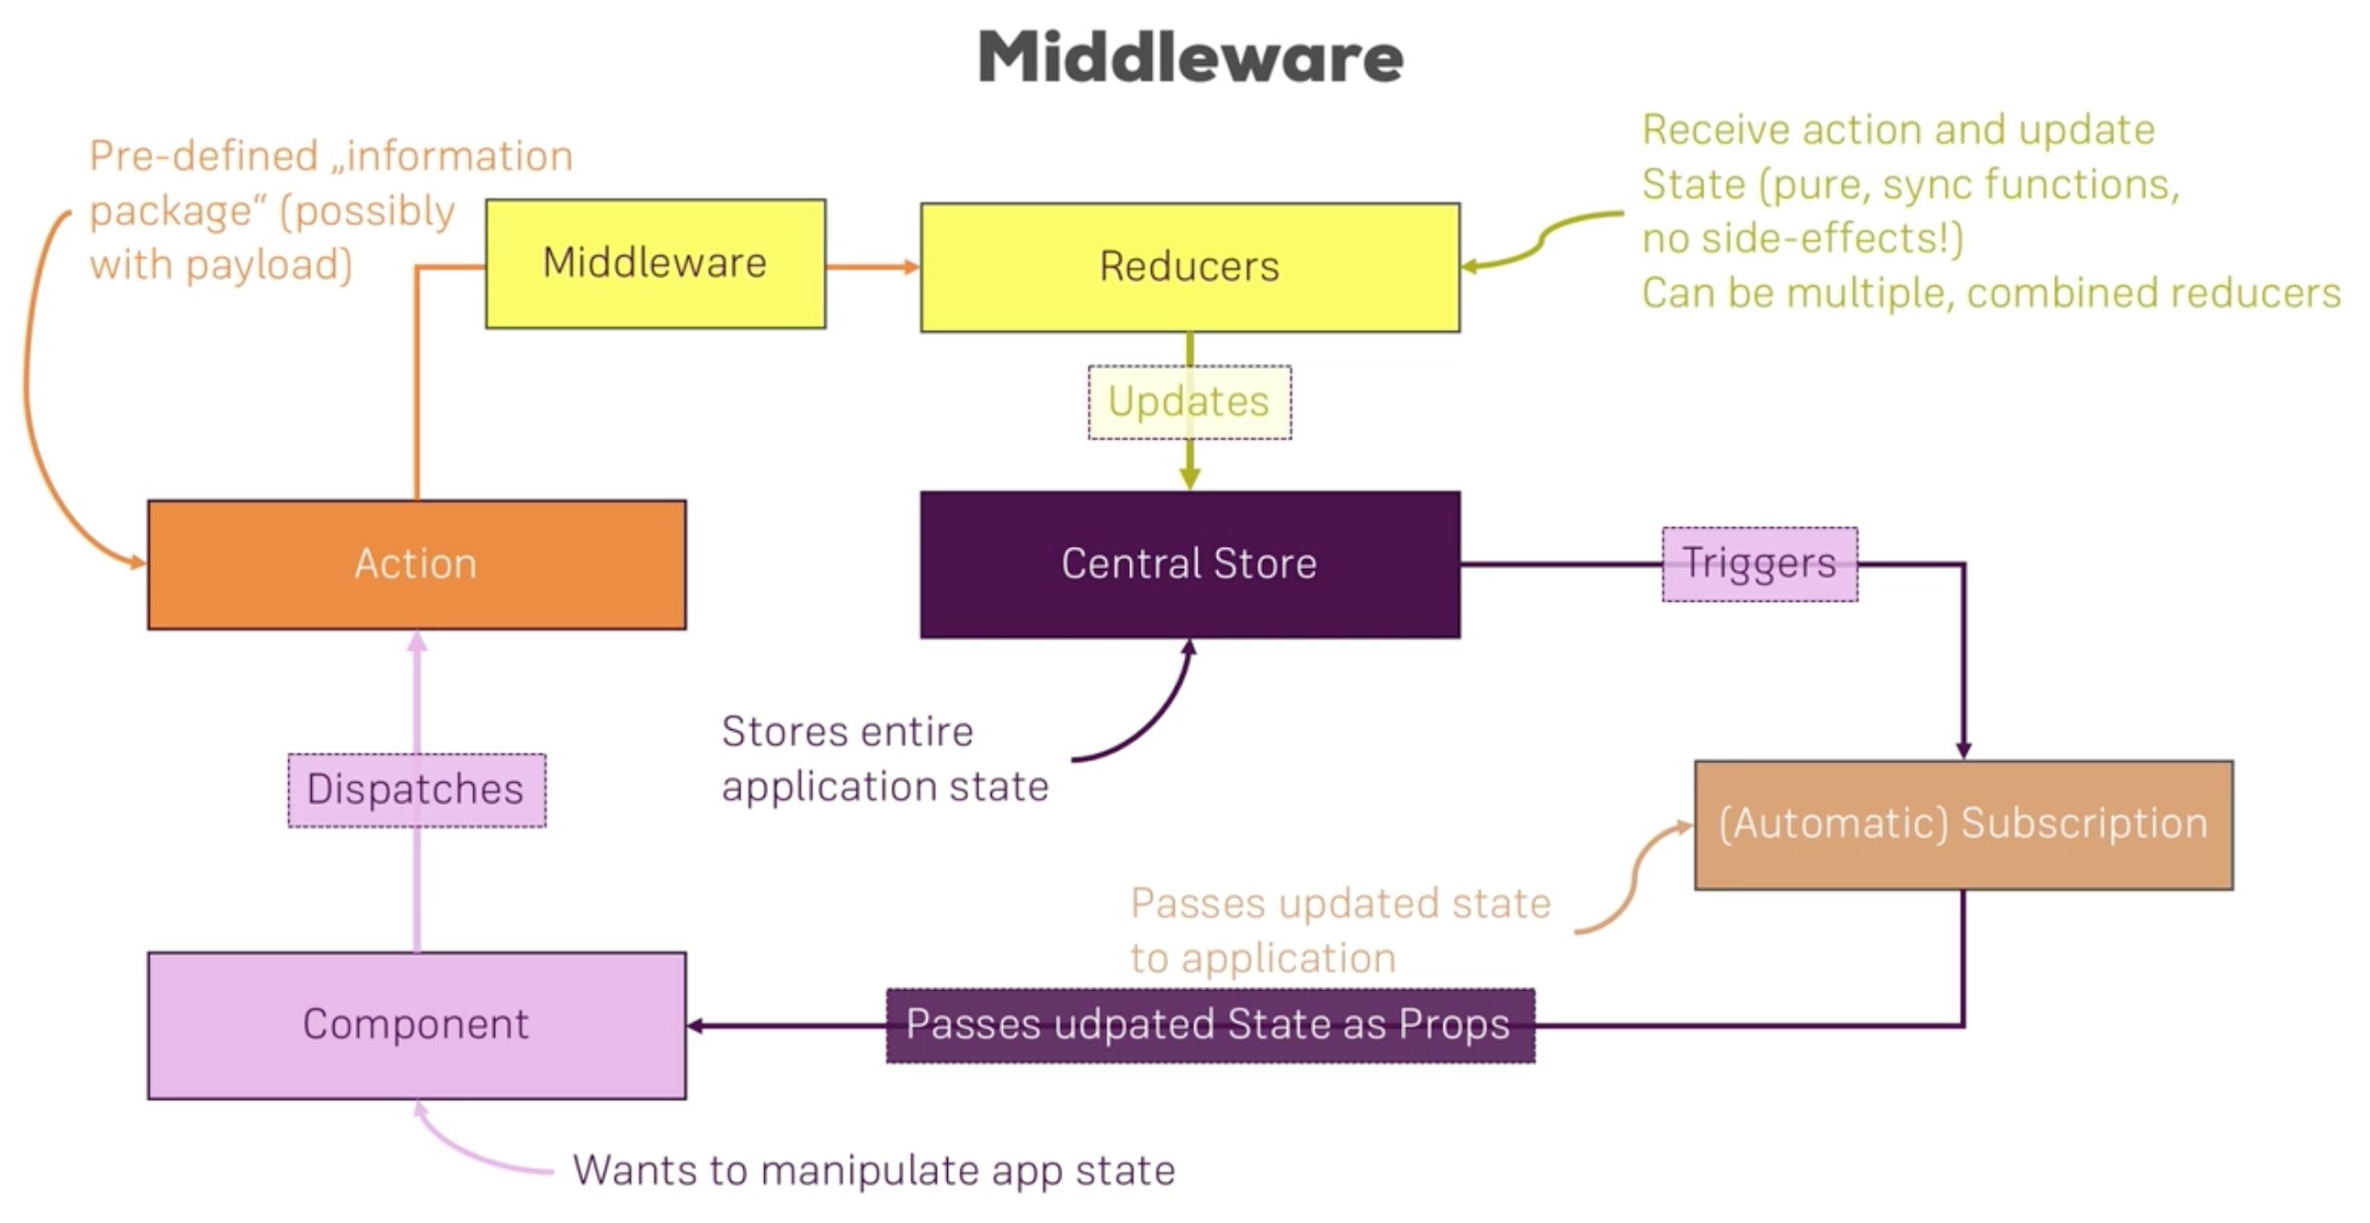

→ Action creators: help us execute asynchronous code in reducers

→ using redux-thunk

→ middleware executes between dispatching an action and reaching to the reducer

→ in action creator redux-thunk can pass us another argument call getState which gives you gets current state

→ We run async code using thunk between action dispatch and reducer, basically hijack action dispatch flow before it reaches reducer then execute async code and then we can dispatch action to synchronous method and then to reducer

→ during the action dispatch and reducer, if we want to reach out server and update state we should use action creaters

|  |  |
| --- | --- |
| Action creator | Reducer |
| * Run async operations * Can massage data | * Pure, Sync code only * Core reducer concept: which is Update state |

# Questions

How to do two way binding in react?

What is an higher order component ?

What is the difference b/w functional components and class components ?

Difference b/w stateful components and stateless components

Can we see virtual dom objects ?

Ref Vs Props

Pure components vs should component ?

ComponentDidUpdate is called when state is update.

How do you return adjacent JSX elements (without wrapping them in a div) ?

Explain map, reduce, spred in ES6

Difference between const and let

What is a turnery expression ?

Flex box ?

Go through all classes css

JavaScript promises

What do we have in request header ?

Can we have multiple Switch components on one component ?

What are the properties available in ‘props’ ? (regarding request ? like query params….)

Http status codes

201: successful

Inline style = {{}}

Components rendered using routing can only have special properties, like match…., in their props

-talk about nested Route

-Route with render vs Route with component

- If we render component in Route using reder method, we do not have history for that component.

- Link vs NavLink

- explain object.assign

-array vs concat and splis vs filter

-How to add constants ? export const INCREMENT = ‘INCREMENT’

- explain ES6 array Concat